ENGG3961 Final Report 2024

Full Name: CHEUNG Dick Ho
Student ID: 20857899
Major Program: CPEG
Sub-team: Robocon
Role including both technical and non-technical role (if any):
- WD R1 SW Senior
- Game Rule/FAQ/Appeal member PIC
- WD R2 Embedded SW

Part 1 – Technical Documentation
In this part, please write all the parts of your robot that involved your contributions, pictures are recommended. Please also include all the necessary documentation, graphics and explanation. These will be saved in the robotics team library.
Part 1a – Project 1
Project Classification (Mechanical / Electronics / Software / Business / Management)
Software / Management

Project Title
2024 R1 Software - Juniors management and training

Objective and Methodology
I am in charge of leading and teaching all 4 R1 SW juniors on Gen0 R1.
We have 301 commits for 2024-Gen0-R1.
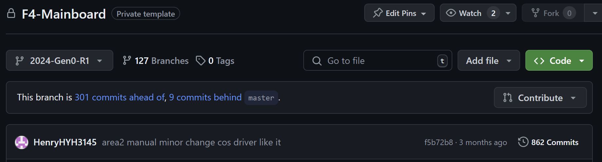
After Gen 1 finished assembled, I am in charge of leading my 2 WD R1 SW juniors on WD Gen1 R1 and WD Gen2 R1.
We have 214 commits for 2024-WD-R1. (both Gen1 and Gen2)
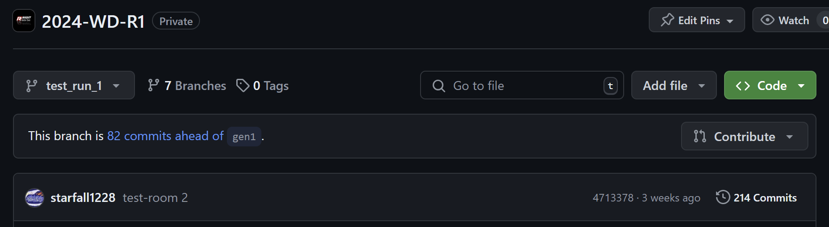

2024 Gen0 R1 Management
Since the juniors have not yet familiar with the structure of a full robot yet, I wrote the frame of most of the program and let the juniors write the code inside the frame. So, the juniors can learn the structure while writing the codes inside the frame and I can maintain the overall structure and format of the whole program. Making sure different parts of the code won’t have conflicts and can work well together.

Part of my commits in January/February when I am writing the structure: (I am DicaprioCheung)
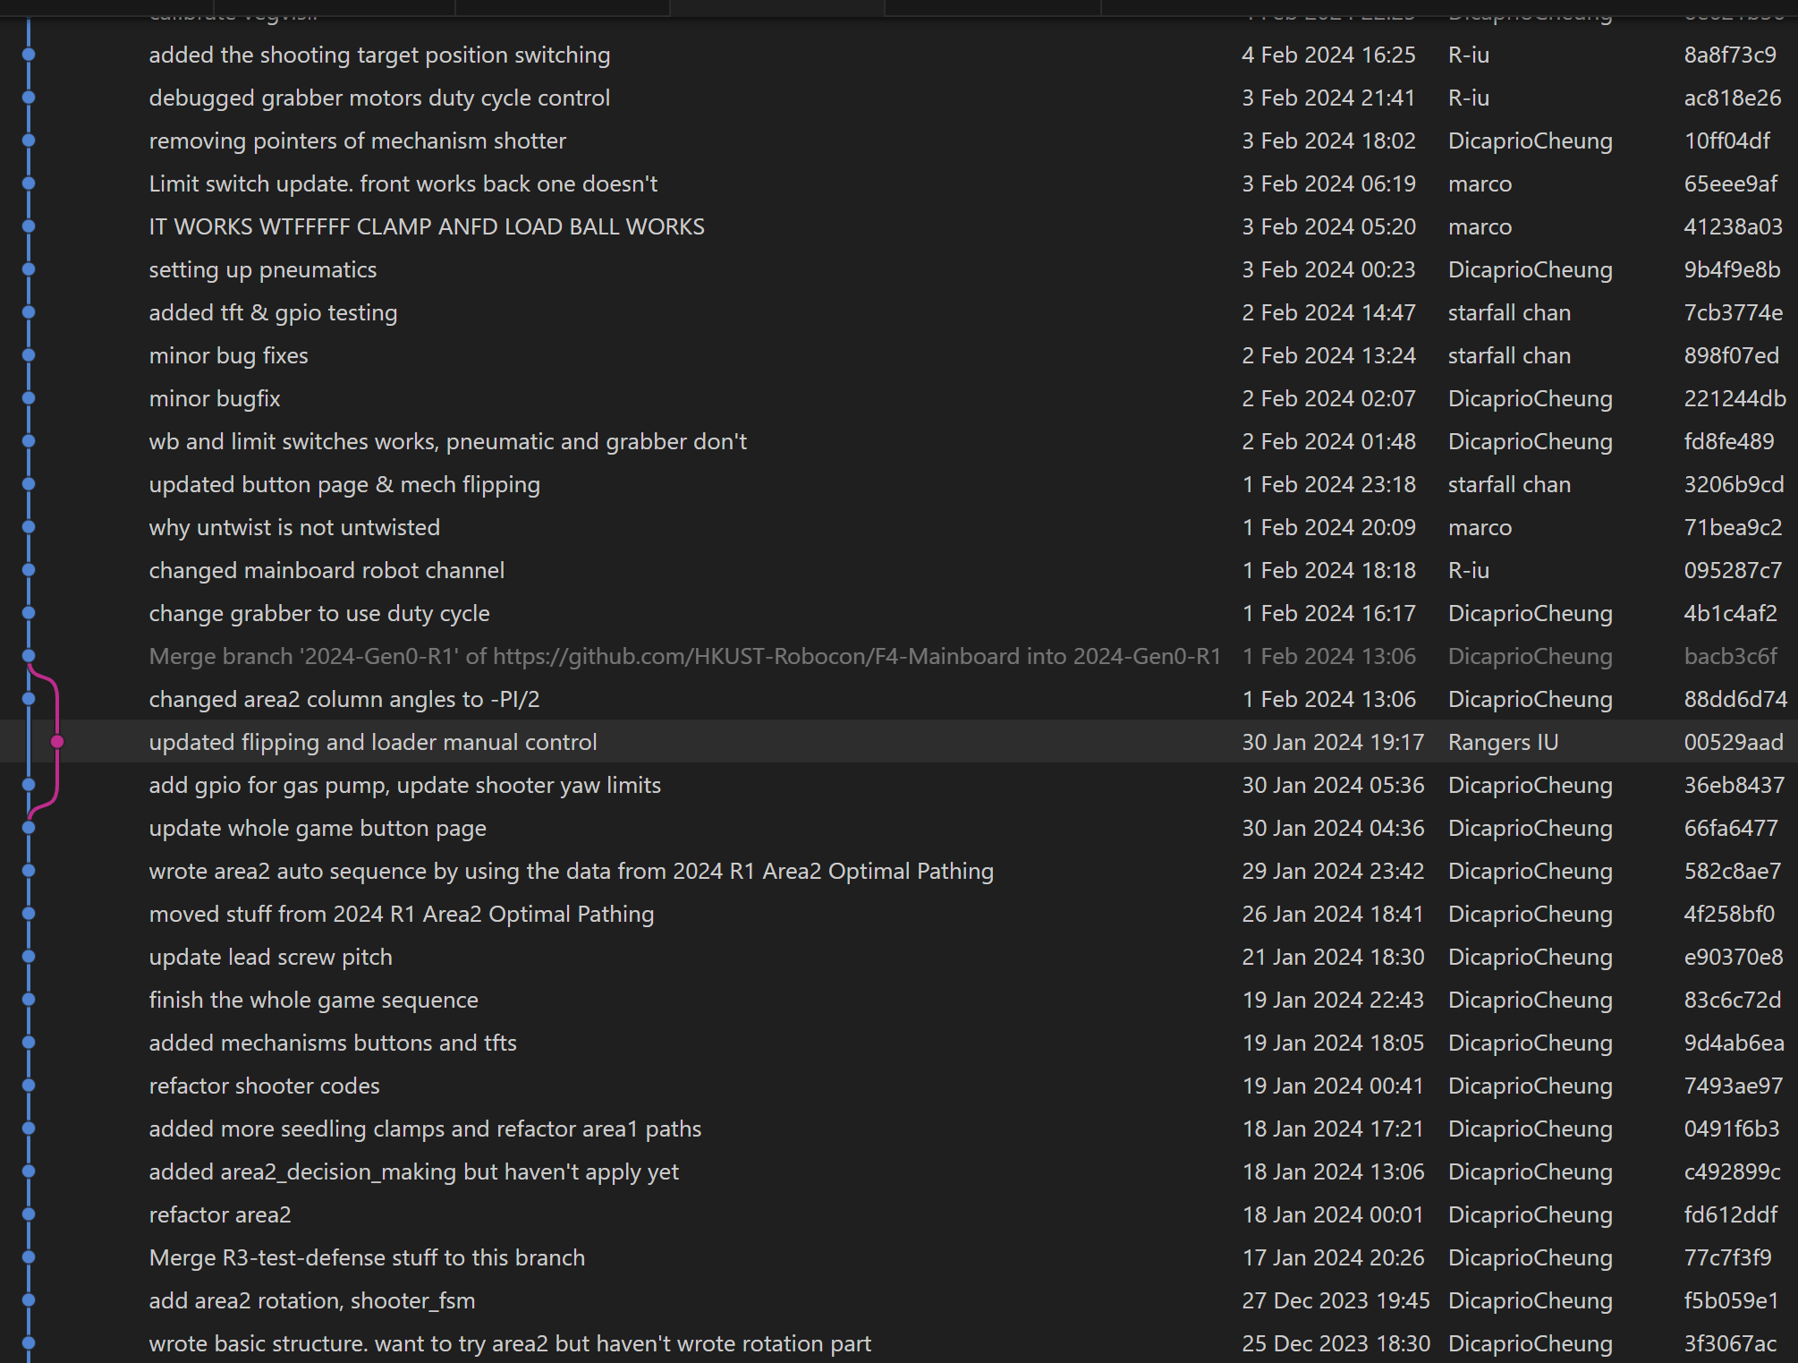

2024 WD Gen 1 R1 Management
Since my juniors learned most of the basic structure of a production repo, I let my junior to write most of the structure of Gen1 R1 code so that they can gain experience in designing the structure. So, the code for WD Gen 1 R1 is quite different to Gen 0 code (as opposed to FD Gen 1 R1 who basically used the structure of Gen 0 R1). I also oversee FD Gen 1 R1 for a bit to make sure they can transfer from Gen 0 to Gen 1 smoothly.

2024 WD Gen 2 R1 Management
Since gen1 and gen2 is mostly similar, I decided to give everything to my juniors to tune. I would only tune when my juniors are not in lab. This allows my juniors to learn how to make decisions on the robot designs. As I have nothing to do, I went to help WD R2 to win the competition.

Test Result
I slowly teach and pass the technical part of the robot to my juniors so that my juniors can learn and pick up the technical skills and even some management skill along the way. Every day after I leave the lab, I would send out a long progress list and a long to-do list so that everyone know what is happening about the robot and know what to do. Maybe influenced by me (or my very long never-ending to-do list), my juniors are very passionate on robot tuning and loves to stay overnight even not in day-night shift
e.g.
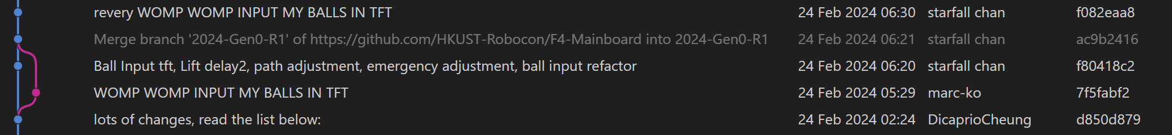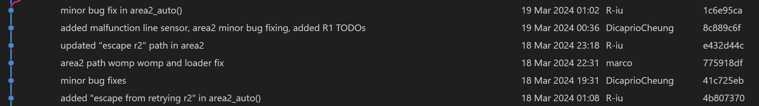
Since R1 team is very active and tune robots overnight, R1 progress is much faster when compared to R2 progress. Moreover, R1 juniors have more sense of belonging to the team and is more willing to come back to lab to tune robot and stay in the team next year.

Summary, Improvement and Further Development
To summarize, management is a very crucial and challenging task. Good management can motivate others to work overnight while bad management can make people wants to quit team. By slowly passing the technical skills to the juniors until the whole robot is passed to them, the juniors can then learn all necessary technical and even management skills. So, they can gain the necessary skills to become seniors next year immediately after the competition.

A progress list can let everyone know what is happening everyday so people can pick back up even if they did not come to lab for a few days. A to-do list of small but useful tasks can let people know what they can do/what they need to do so that they have a purpose to come back to lab. People completing the tasks on the to-do list would gain sense of fulfillment, which would then fuel their passion and motivate them to continue working on the robot and make it better.

It is a shame that juniors are not much involved in the design process of the robot due to our tight schedule and bad communication. It would be much better if we can host a big meeting with everyone and let everyone propose different robot ideas. Then compare different robots with everyone and vote before drawing each gen robot.

Part 1b – Project 2

Project Classification (Mechanical / Electronics / Software / Business / Management)
Software

Project Title
2024 R1 Software - Technical

Objective and Methodology
For 2024 R1, the code can be split into 5 parts:

Part 1: Area 1 Seedling Planting Pathing
Our robots have 4 seedlings clamps in 1 side. So, we can grab 4 seedlings, then plant 2 and plant 2. There are 12 seedlings in total. So, there are 3 different groups of seedlings. Our robot is highly automatically, but we still keep the ability to switch to manual (and switch it back) anytime in between the auto paths in case of emergencies.

We split the paths into 5 different main states: Start zone, Seedlings 1~4, Seedlings 5~8, Seedlings 9~12, Area2. We tuned most auto paths (combinations of trapezoidal paths and Bezier paths) to go from any states to any states. This allow us to do all different strategies like “plant 12 -> area 2”, “plant 4 -> area 2 -> plant 8”, “plant 8 -> area 2 -> plant 4”, “plant 4 -> area 2 -> plant 4 -> area 2 -> plant 4”, “plant seedling 5~8 first -> area 2 -> plant remaining seedlings”, etc. The state from Area2 to Start Zone allow us to retry very quickly using auto paths.
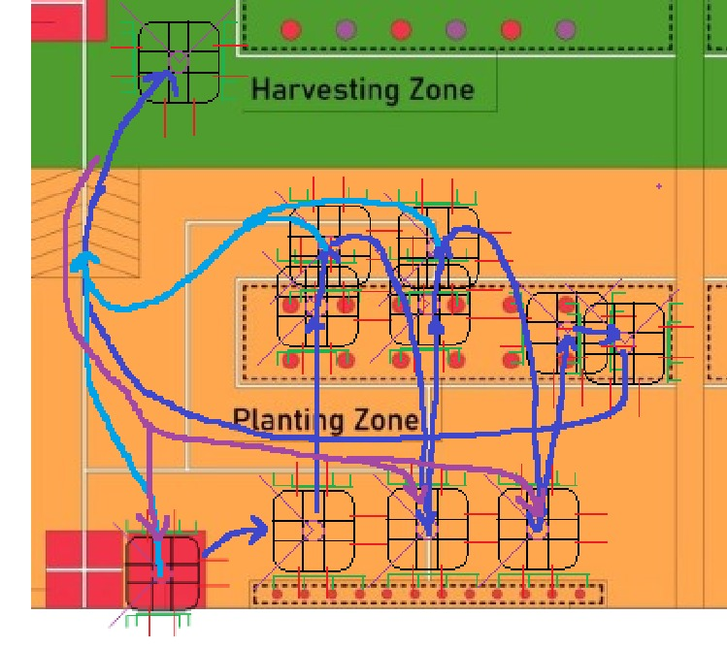(This is not the latest paths)
Part 2: Area 2 Track Following Pathing
This is the part where I put most of the time on. Our R1 has a tunnel in the middle of the robot so that we can move pass the balls without touching them. This limits our robot to move in a very strict, straight line with only a few cm tolerance. Our robot also need to switch from 1 column/row to another column/row as quickly as possible while maintaining the accuracy of the paths needed. So, I invented this new Track Following Pathing to allow the robot to move along the very low tolerance paths.

Methodology

For straight line,
In the perpendicular direction (grey) to the line, I applied PID such that the robot stays within the few cm tolerance.
In the parallel direction (yellow) to the line,
When manual, it takes the joystick reading in the same direction and move relative to joystick reading
When auto, I applied trapezoidal pathing so the robot accelerates and decelerates and maximum acceleration and deceleration so our robot moves along the path with maximum speed.
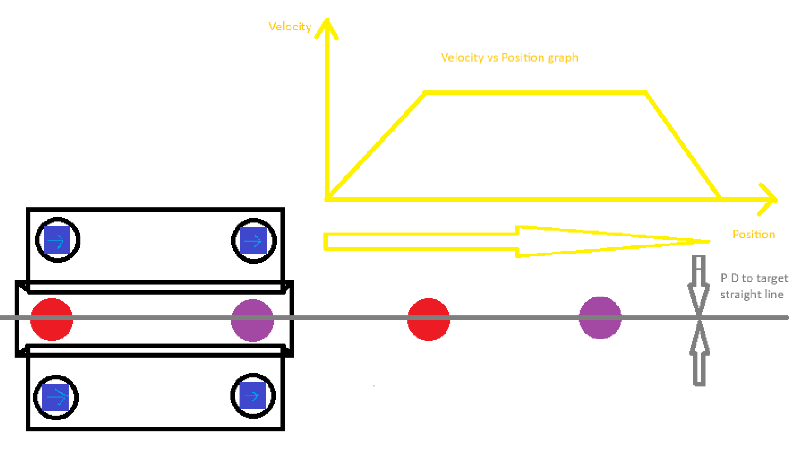
For curve arcs, the coordinates of the center of the arc/circle is defined. With the coordinates of the current position of the wheelbase, the perpendicular direction (gray) and the tangent/parallel direction(yellow) can be calculated.
In the perpendicular direction, PID is applied to maintain the same radius from the arc center.
In the tangent/parallel direction,
When manual, the joystick magnitude in the ever-changing tangent direction is used as the speed of the robot
When auto, a constant speed is applied along the tangent direction such that we can move along the arc.

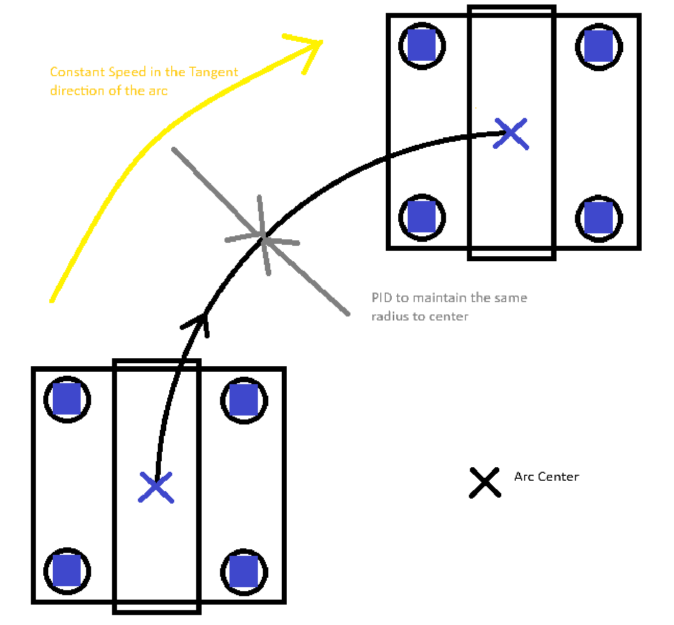
By combining many sections of straight lines and curve arcs, the following tracks are built on Area 2 to allow the robot to go to any balls from any other balls using semi-manual/auto.
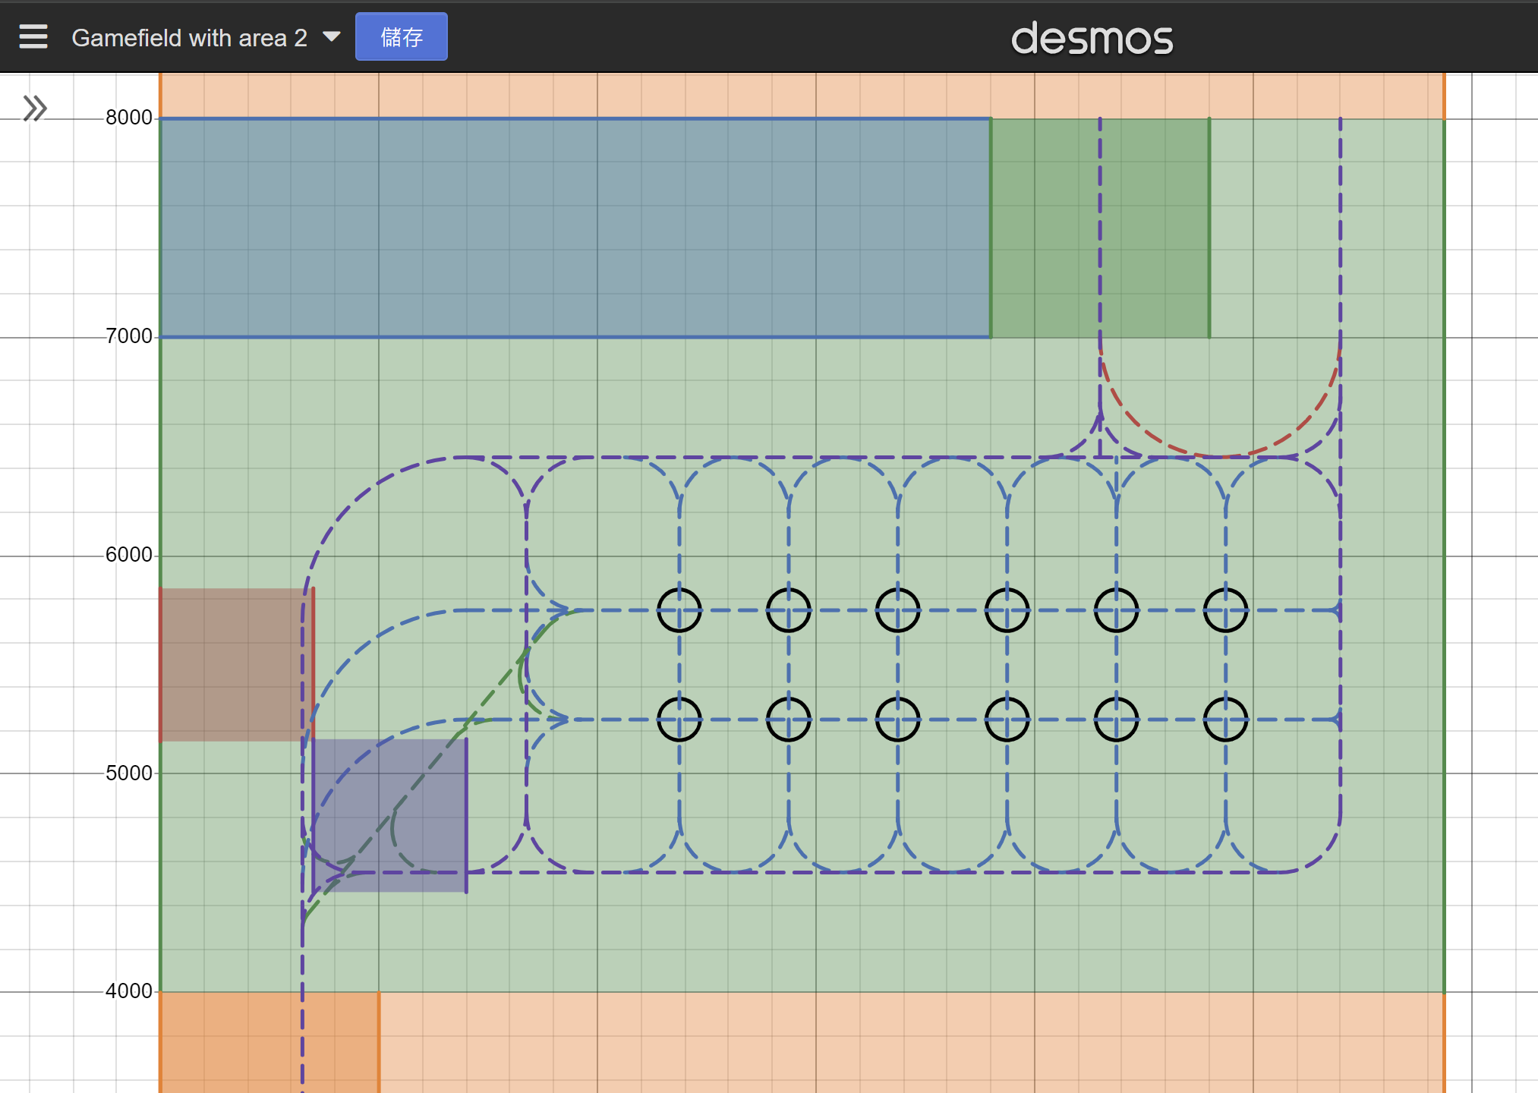

Shooter regression

Laser Line sensor positioning

Red-Blue Field Flipping

Semi-Manual:
The robot would stay on the track as written above. Driver can use the joystick to control the robot to move along the tracks. When the robot approaches an intersection, if the driver’s joystick is trying to switch to another line, the robot would automatically switch track from the current straight line into the connecting circular arc. This allows the driver to drive freely while assisting the driver not to hit the balls in the Harvesting Zone.

Semi-Auto:
In this mode, the driver only needs to choose the destination of the robot (i.e. which ball she wants the robot to go). Then, the robot would go to the destination automatically using the shortest path using trapezoidal pathing for all straight lines. I wrote a hard-code recursive algorithm to handle this auto-paths:
Area 2 Semi-Auto Algorithm methodology:
If destination is on my current track, move to destination //end condition for recursion

Given the current track and destination track, move to the next hard-coded target track (that is closer to the destination)
When we arrive at the next target track,
Update current track as next target track
We will run this algorithm again //recursive part

Full-Auto (We didn’t use this in competition due to its low flexibility):
In this mode, the driver only need to input which balls are red/blue before the robot goes onto Area 2. Then, the robot would finish all Area 2 tasks automatically without any driver control. Given the ball pattern, I can simulate all possibilities of the paths by using a simple recursive brute force algorithm:
Area 2 Full-Auto Algorithm methodology:
If no balls left, return 0 //end condition for recursion

Given the color of the next ball,
For every ball on the field with that color,
Compute the time needed to go to that ball
Run this algorithm again with that ball removed //recursive part
Travelling time for this possibility = the travelling time to the ball + the return value of the recursive part
Return the possibility with the shortest travelling time
Although I did a lot of different optimizations to increase its speed, the algorithm above still takes quite a long time to run. Since I found out there are only 924 different combinations in Area 2, I decided to pre-compute all combinations on my computer and input the resulting data of the path into the robot instead. The data assumes we follows the shortest time path. So, if we don’t follow it, we have to compute a new path in real time, which is why Full-Auto is not flexible.

Part 3: Shooter regression

Part 4: Laser Line sensor positioning

Part 5: Red-Blue Field Flipping

Part 3: Shooter regression
Objective
In Area 2, from any position our robot is in, shoot the ball to any given coordinates accurately using our flywheel shooter.

Methodology
Given the x, y, coordinates of the robot’s current position and the target shooting position, we can calculate the angle and the distance between the robot and the target position.

For the angle,
Given the (global) angle of the robot and the (global) angle we need to shoot, we can easily calculate the local angle of the flywheel shooter that it needs to aim at. After calculating the gear ratios on the flywheel shooter and the motor, we can then calculate how much the yaw motor of the shooter needs to rotate.

For the distance,
We tested the shooter to shoot at different speed and the final distance the ball has flew for more than 200 times. We plot the data on the graph with an Excel sheet. By applying linear regression/polynomial regression on the distance and the shooter velocity, we can then find the relationship between them. By using the regression formula, given the shooting distance we need, we can then calculate what velocity the flywheel needs to spin in order to shoot the ball to the target position.
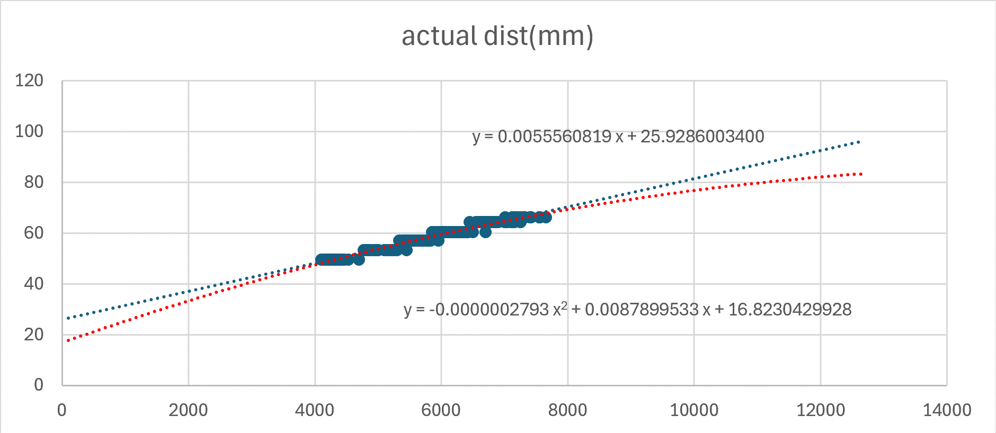
x-axis: ball flying distance(mm)
y-axis: shooter flywheel velocity(rev/s)
blue line: linear regression best fit line
red line: quadratic regression best fit line
Part 4: Laser Line sensor positioning
Objectives
To re-calibrate the xy-encoder from anywhere in the gamefield
To fuse all sensor data we got from xy-encoder, imu, 6 lasers, 3 line sensor bars
To fix the inaccurate xy encoder due to the slopes this year
To have a very accurate robot position so that we can tunnel the balls in Area 2 accurately without hitting them

Why so many lasers
I know that I am being challenged why I need 6 or even 8 DT-50 lasers on 1 robot. :P
There are a few reasons why I need so many sensors
- there are many balls and seedlings on the ground that blocks my lasers
- there are slopes and seedling rack where I can’t get accurate laser reading
- there is no fence on the bottom part of Area 2 for lasers to shine onto
- there is a R2 in Start Zone/Retry Zone

Line sensor bar Methodology
Our line sensor bar has 8 line sensors. Each of them are 12 mm apart. With 7mm gaps in between.
With the 30 mm white lines on the game field, sometimes it might have 2 sensors on, sometimes it might have 3.
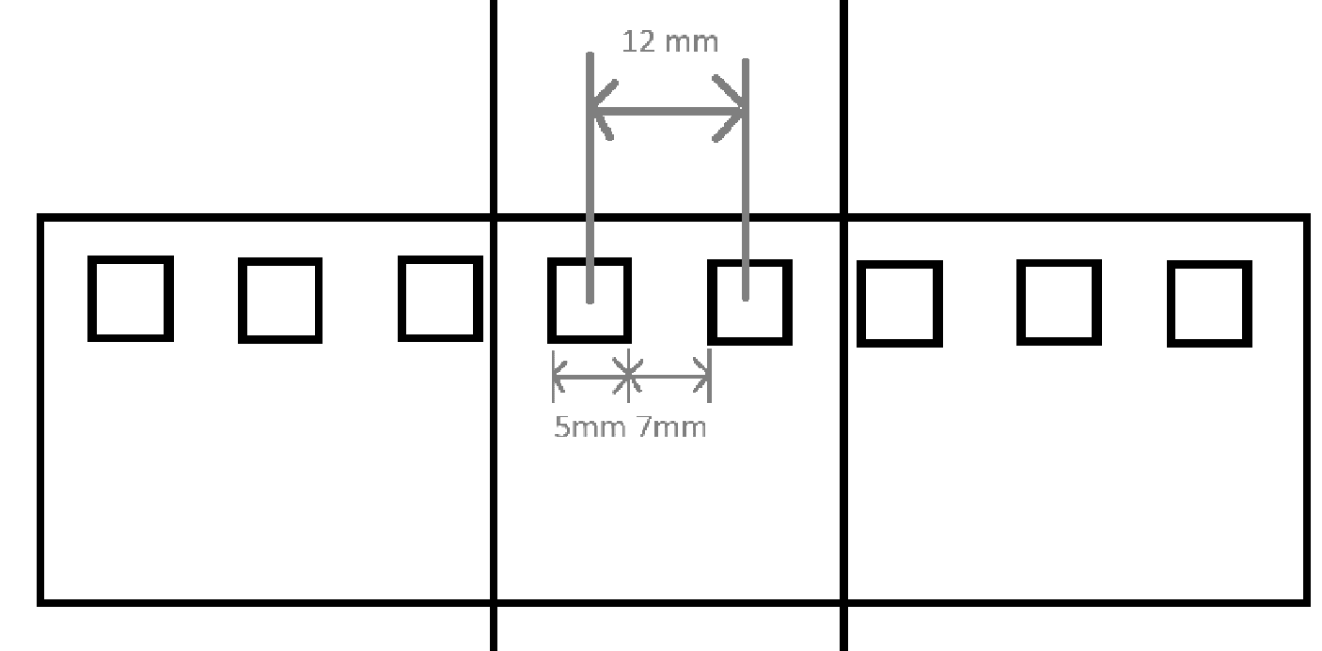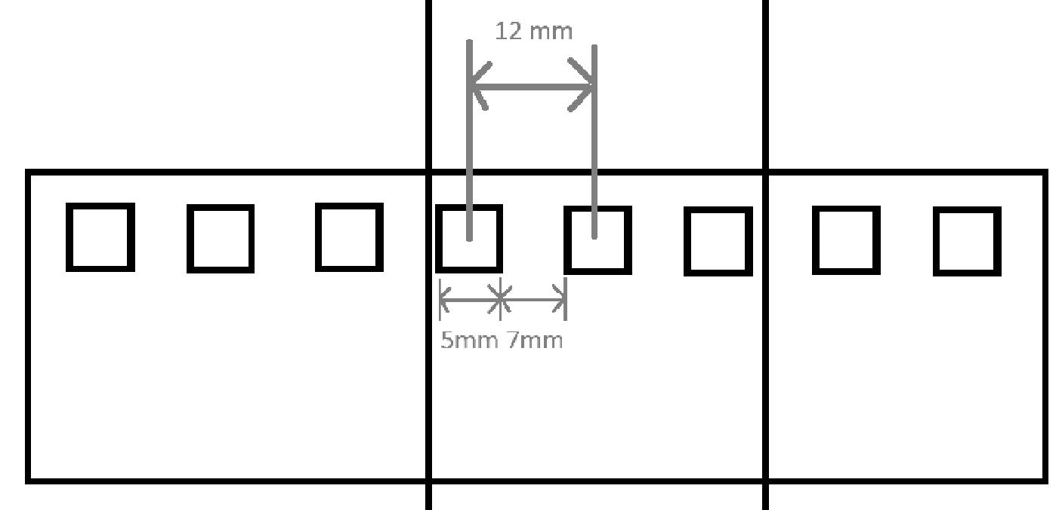
This allow us to have a more accurate reading from the line sensor bar because
00011000 (2 line sensors in the middle senses white) +-0
00011100 (3 line sensors to the right senses white) +6 mm
00001100 (2 line sensors to the right senses white) +12 mm
all represents the white line in different positions. This allows the line sensor bar to have 6 mm accuracy even though the sensors are 12 mm part.

Methodology
By using the old xy-encoder reading, we have a rough idea where our robot is and where the nearest fences are. Using all available sensors(lasers, line sensors) that are not facing the slopes, the seedling rack, and the void, we would compute the x and y coordinates of the robot calculated from the sensor readings (with angle corrected using imu angle data). If there are multiple sensors calculating the same axis(x or y axis), we would then compare their calculated values with each other and the xy-encoder reading. We can then know that some of the sensors are blocked by seedlings/balls and can be ignored. We would re-calibrate with the remaining sensor values.

Part 5: Red-Blue Field Flipping

Part 5: Red-Blue Field Flipping
Background
This year, the game field is left-right reflectional symmetrical. So, the paths and the code for red field and blue field is different because one of them goes left and the other goes right. So we came up with the following hypothesis

Hypothesis
If we flip all the sensor inputs and flip all the output actuators, then we only need to write code for 1 side of the field
*flip = reflect along the line x = 6000 (center of red/blue field)

Difficulties
This sounds easy but very challenging when applied.
Challenging points
- Our robot is not fully symmetrical. Not everything can be flipped. So, we have to allow some part of the code to be different for red/blue field while flipping the remaining code. This makes our code very confusing because something is flipped twice and remains un-flipped while something is flipped thrice in 3 different locations
- Our robot is not perfect. Our center of gravity is not perfectly in the middle. So, red/blue field need different fine-tuned offsets to make them accurate even for the flipped paths.
- Different area need different Theta flipping strategy. Apart from flipping x, we also need to flip the rotational theta. Since Area 1 and Area 2 uses different mechanisms and they are located on different parts of the robot(Area 1 seedling clamps facing 0 degree, Area 2 Flywheel shooter facing 90 degree), c, Area 1 would like to flip theta in “theta = - theta” way while Area 2 would like to flip theta in “theta = 90 degree – theta” way. This causes conflicts in code.

In the end, only Area 2 used this red-blue field flipping.

This concept is good but might need more development next year to fit different situations elegantly.
Test Result
Overall, I think R1 is a success as it is one of the fastest R1 in the world, and our R1 don’t have any major errors/retries during the competitions

However, for each part:
Part 1: Area 1 Seedling Planting Pathing
For Area 1, it is quite good as it is one of the fastest in the world. Driver can immediately change to manual whenever she moves the joystick. However, we can improve on the acceleration and the deceleration of the trapezoidal paths. We set its acceleration to be 32 ms⁻², which is obviously way too big. So, the tires are slipping all the time and the black tires wears out in a week. I believe if the acceleration is tuned to the exact maximum possible acceleration instead of much higher than that, the wearing problem of the tires can be lessened.

Part 2: Area 2 Track Following Pathing
Although I put a lot of time in this, however the results are not as good as I expected. My original idea is that curve arcs can maintain the speed of the previous track so that we doesn’t have to stop to 0 velocity when changing track. However, after the arcs, the errors are too big. The robot has to stop there and do pre-steering in order to maintain the accuracy we need. That is why WD R1 looks much slower than FD R1 in Area 2.

Part 3: Shooter regression
There is a yaw offset that we did not expected. The ball is not landing directly in front of the shooter but slightly to the right. This causes inaccuracy and un-symmetrical between red/blue field and causes a lot of problems for us.

Part 4: Laser Line sensor positioning
The math and the codes are way too complicated. This causes the readability of this code to be very low ad no one can understand and debug this code. We still don’t know if our math is correct or not. :P

Part 5: Red-Blue Field Flipping
This concept work as expected but I hope it can be more readable and generalized in the future.

Summary, Improvement and Further Development
Part 1, 3, and 4 are our traditional technologies that we need to pass down while Part 2, 5 are new concepts that we created this year. I hope we can continue to improve our exisiting technologies while further developing new ones in the future.
Part 1c – Project 3

Project Classification (Mechanical / Electronics / Software / Business / Management)
Software

Project Title
Trajplanner research and upgrade
Objective and Methodology
Background:
Trajplanner is the tool for SW to draw Bezier paths. It is one of our technical advantages that we have against other Robocon universities

Objectives:
To maintain Trajplanner such that it is bug-free
To make Trajplanner more easy to use and learn such that new recruits can pick it up easily
To update Trajplanner such that it fits the current libraries
To understand what our previous ancestors wrote and try to improve it
To re-discover some old functions that is hidden inside the code and no one knows about

New features:
Help Window
I found out that no one would open its documentation to find out how to use Trajplanner because no one knows where the documentation is. So, I added a Help Window for people to read so that new recruits can learn how to use Trajplanner easily and old member can discover some rare functions easily without finding and reading its documentation.

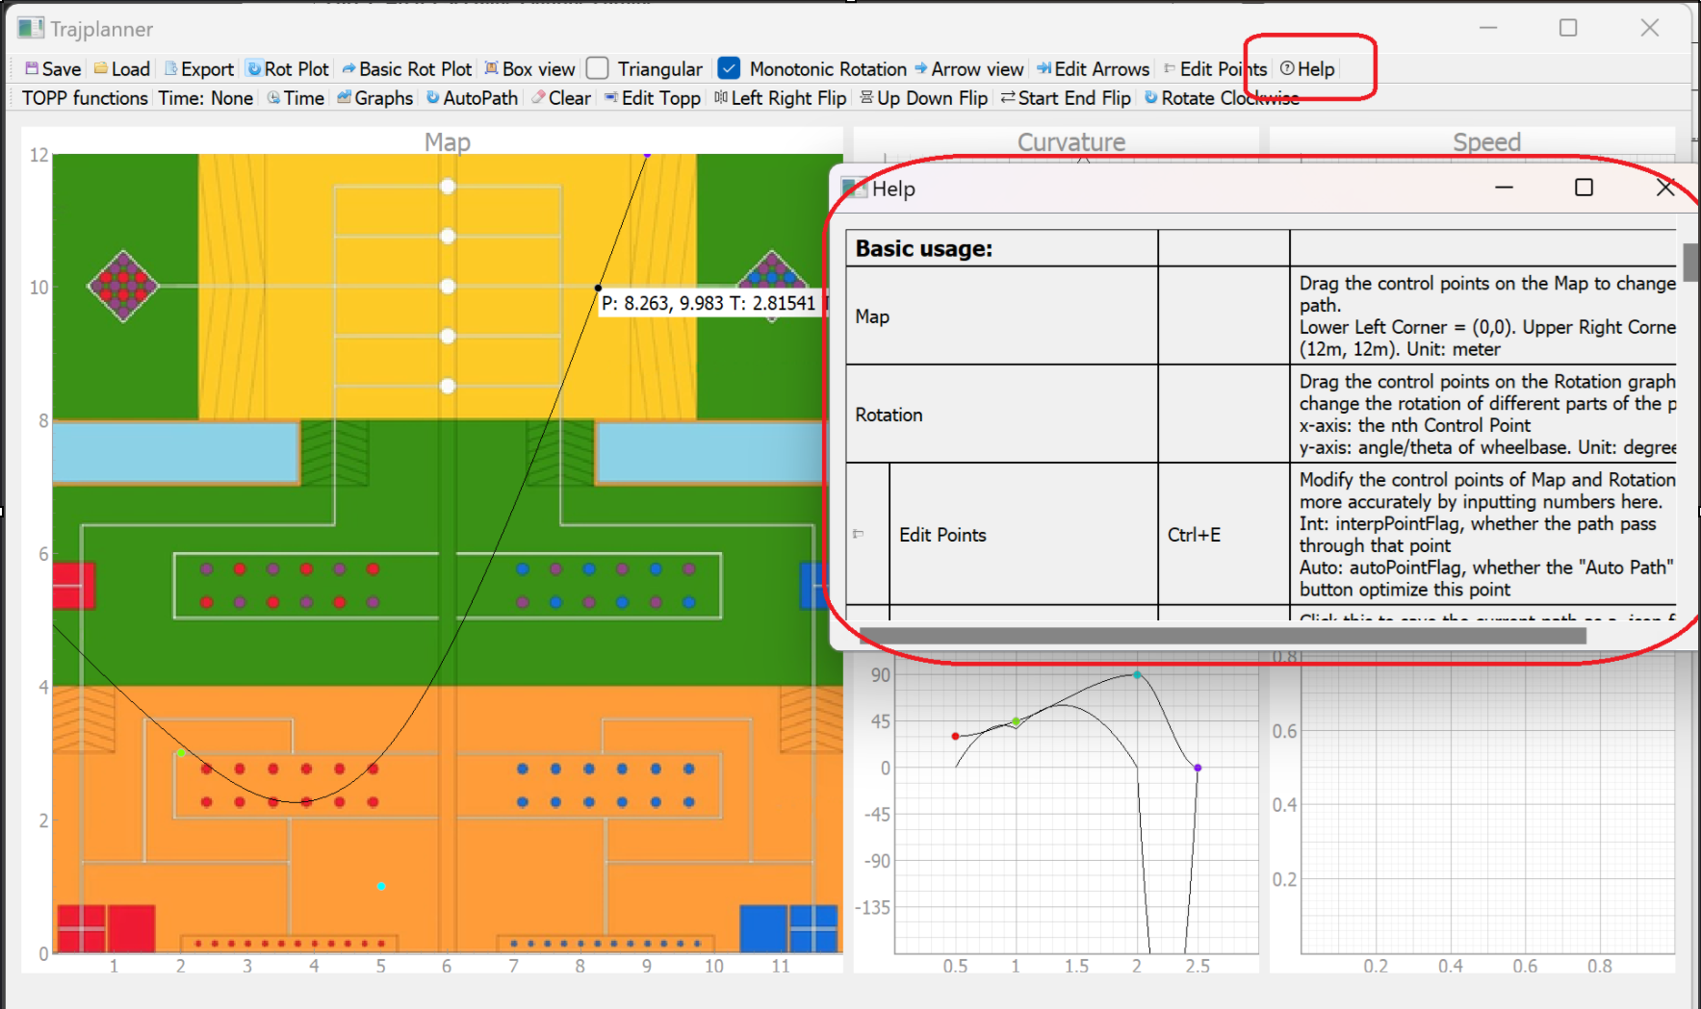
Flipping functions
Since our game field is left-right symmetrical this year, it would be very convenient to have a button to flip the paths from red field to blue field. So, I added this feature along with other flipping directions in case future years’ game field is symmetrical in other directions.
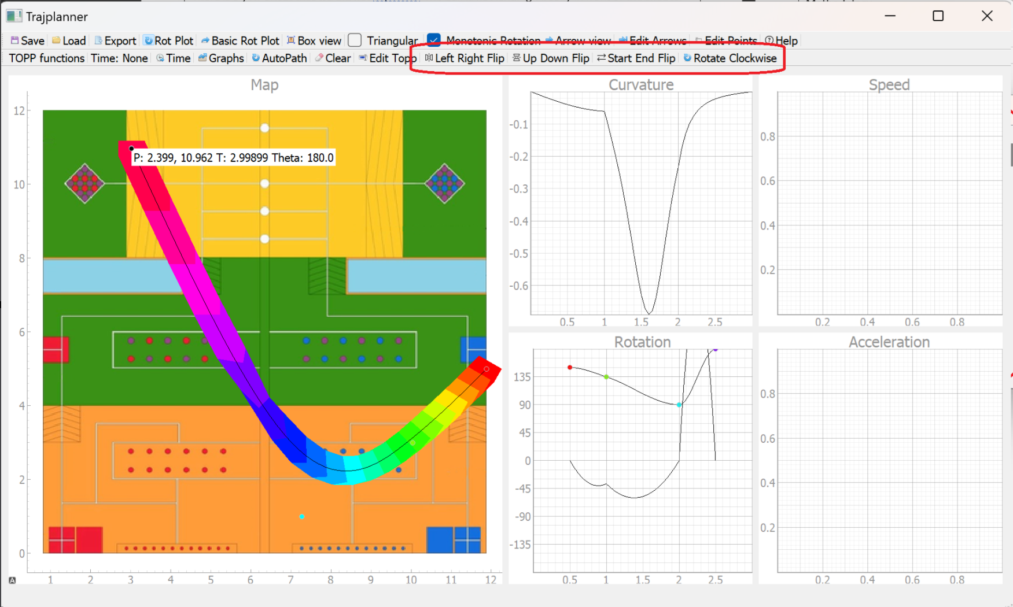

Start End Velocity
I re-discovered that there is a start_vel = 0, end_vel = 0 in the parameters of a function inside Trajplanner. So, I created the GUI in Trajplanner such that we can modify the starting velocity and ending velocity of our paths. I applied this to the starting paths of WD R2 and our R2 jump starts very quickly during the competition.
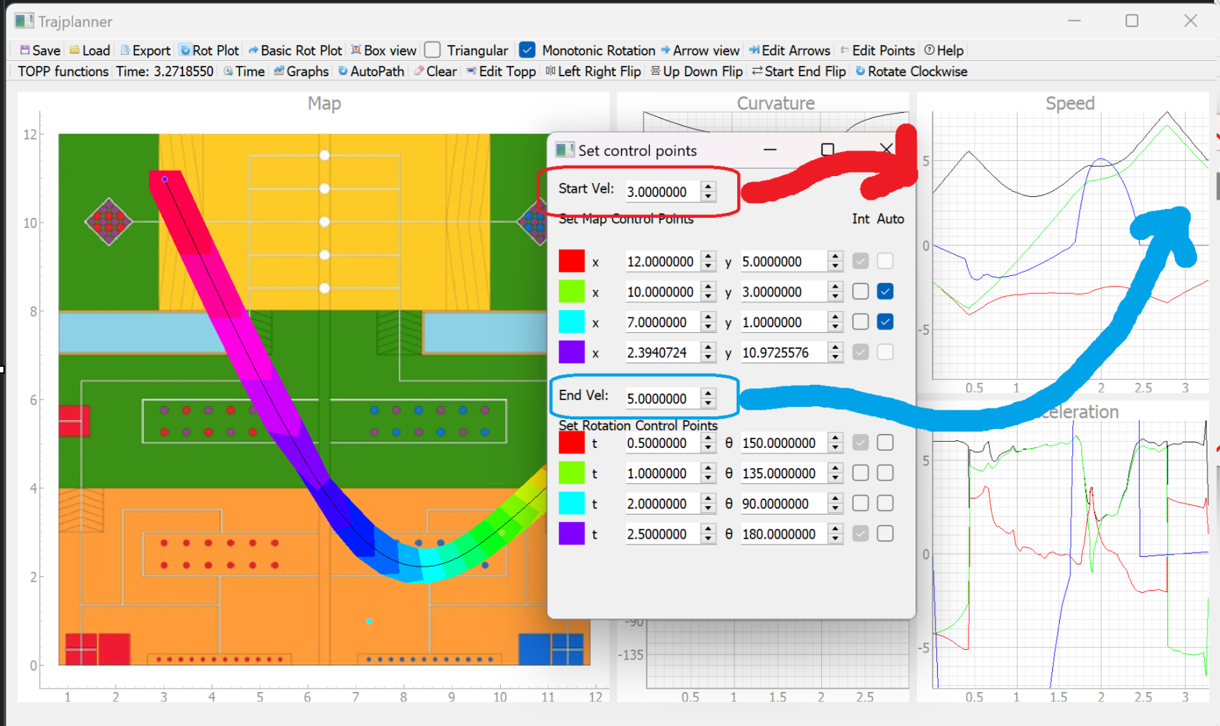
Memory optimization
Each Bezier path takes around 0.5% of our Flash memory on our mainboard. With 10+ paths * 2(red/blue field), it takes quite a lot of memory: (2024 WD R1)
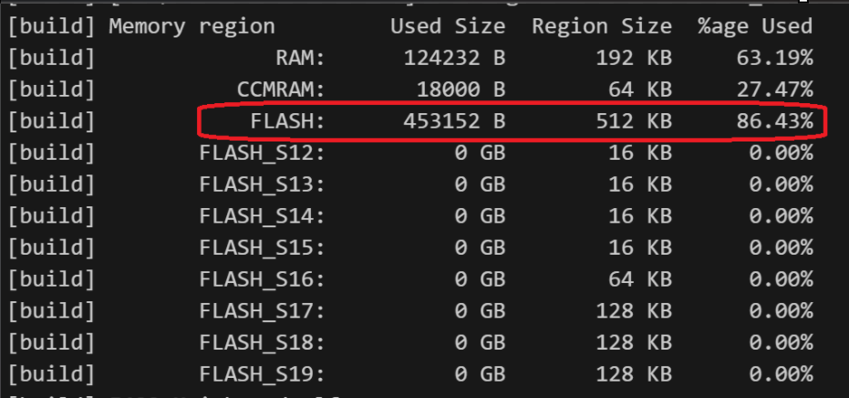
In 2023, we developed wheelbase library in mainboard and we wasted a lot of time and effort to translate the Trajplanner output data and functions in mainboard Bezier paths. I found that there are many useless data and repetitive functions between Trajplanner output and mainboard code that eats up a lot of memory and computing power. That is why I decided to optimize the Trajplanner output to match the need of mainboard and remove unnecessary codes. I finished writing it just before winter training starts but I am not confident enough to let new members to try and debug for me. So, I didn’t merge this part yet.
Test Result
Help Window
During the winter training, this year’s juniors learns trajplanner very quickly as they can read from the Help Window whenever they don’t know how to use. So, they don’t need to waste time randomly trying Trajplanner functions and focus onto path tuning

Flipping functions
The Left Right Flip increases the path tuning efficiency of all 4 robots especially during Test Room and Test Run because we can directly flip all red field paths into blue field paths with a click of the button. This allow us to learn more about our robot and the gamefield instead of wasting time calculating and dragging the paths

Start End Velocity
Start End Velocity is a revolutionary feature that I re-discovered deep inside the code. It allows us to start with a high speed for jump starting and end with a high speed to continue on other paths seamlessly. Since I discovered this function in mid-June, I don’t have enough time for testing its full potential. I hope next year SW can continue to test the limits of our robot.

Memory optimization
I need more time and tests to make sure it has no bugs. Since this would affect all robots, we have to test it thoroughly before merging it into our competition code.

Summary, Improvement and Further Development
I need next year SW to pick up my work. I need people to update the Help Window and the Flipping functions to fit each year’s competition field.

Start End Velocity has a lot of potentials. Such as Bezier path connect to Bezier path seamlessly or Bezier path connect to trapezoidal paths for better acceleration and deceleration. There are many place for improvements and further developments. I hope next year SW can work on this.

Memory optimization needs to be done but it is not urgent. If we switched to ROS, we might not even need to do this optimization. I might try to merge a simpler version this summer so that next year people can test it next year.
Part 1d – Project 4

Project Classification (Mechanical / Electronics / Software / Business / Management)
Software

Project Title
Robotic arm library- Prototype and R&D
Objective and Methodology
In September ~ November last year, we think that robotic arm might be a good R2 design. So, I developed a library for robotic arms.

The library supports:
- 2 axis robotic arm
- 3 axis robotic arm
- 3 axis robotic arm with yaw
- 3 axis robotic arm with yaw and wheelbase

Some Library features:
Basic control
The most basic control by moving each joint/motor to a specific angle

Local coordinates control
By passing in a 2D/3D coordinates (with robotic arm facing angle for high DOF arms) with respective to the base of the robotic arm, after calculating some complex math, the robotic arm moves to the target location.

Global coordinates control
By passing in a 2D/3D coordinates (with robotic arm facing angle for high DOF arms) of the game field, after calculating some complex math, the robotic arm moves to the target location.

Percentage pathing
By calculating the angles of the motors of the current position and the target position, we can find out the angle difference of each motor that they need to travel/spin. After calculating with their respective gear ratios and maximum speed, we can then find out which motors takes the most time to reach its target position.

The motor that takes the maximum time would move at maximum speed. The percentage of the travelled distance of this motor would be calculated. Then, all other motors would move to their respective position of the same percentage such that all motors would reach the target at the same
time.

Bezier pathing
By using the concept of Bezier pathing on wheelbase, I tried to apply the same concept on robotic arms. So, I modified the Trajplanner to simulate the robotic arm(the blue, green and red lines). The circles on the Map are the range that the robotic arm could reach. The Rotation becomes the angle where the robotic arm is pointing at.

Same as wheelbase Bezier path, the output file has many XYTheta coordinates for the arm to follow. So, the robotic arm only need to move to the XYTheta coordinates of the Bezier path using the Local coordinate control above and it would move along the path.

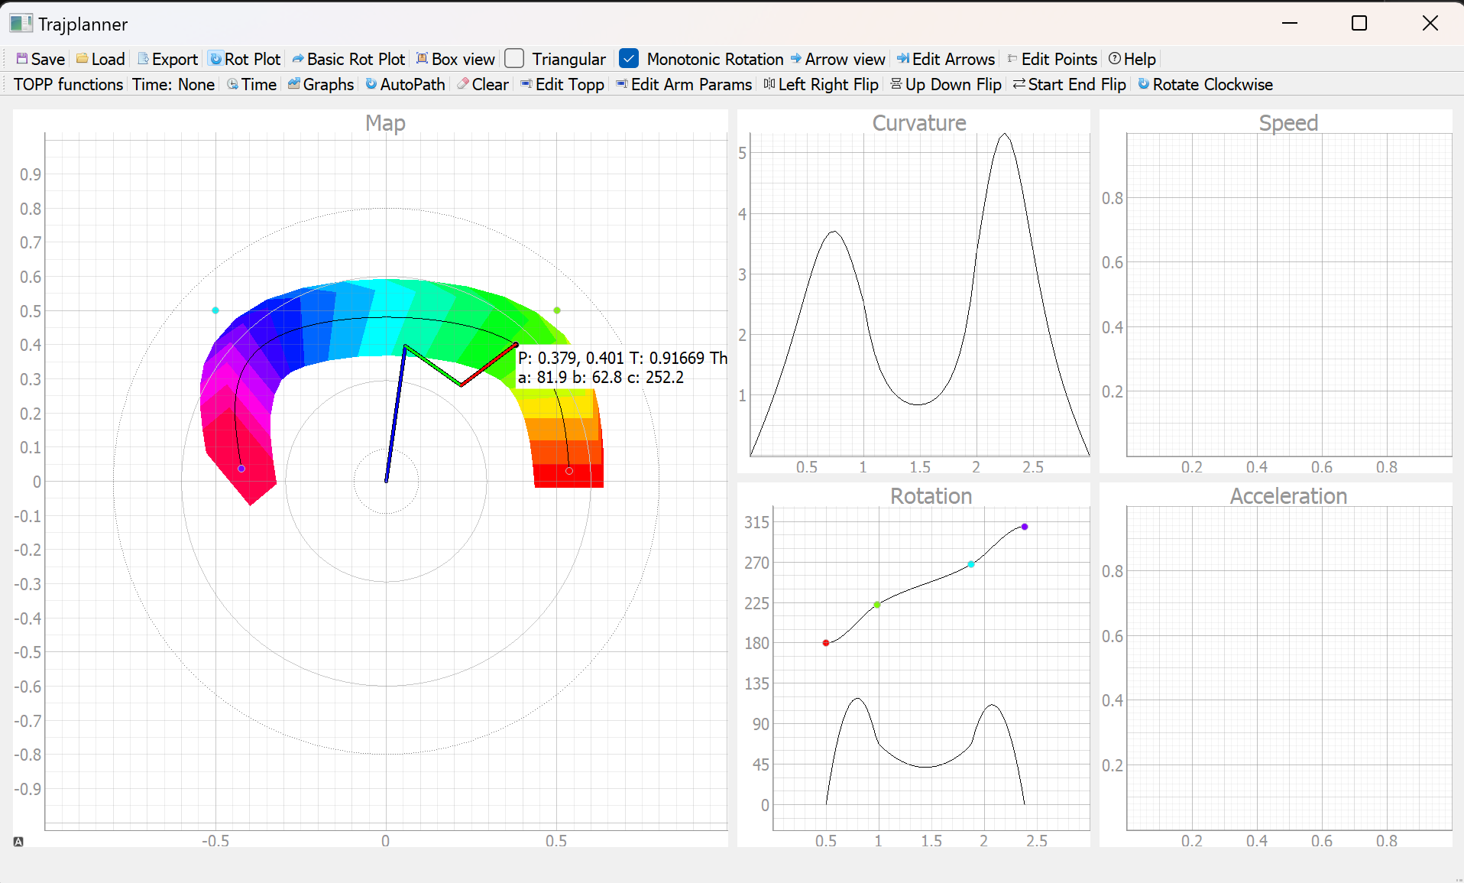

There is an Extra window called “Edit Arm Params”. I can modify the length of the robotic arm and the angle limits of each joint to fit different robotic arms that Mech made.
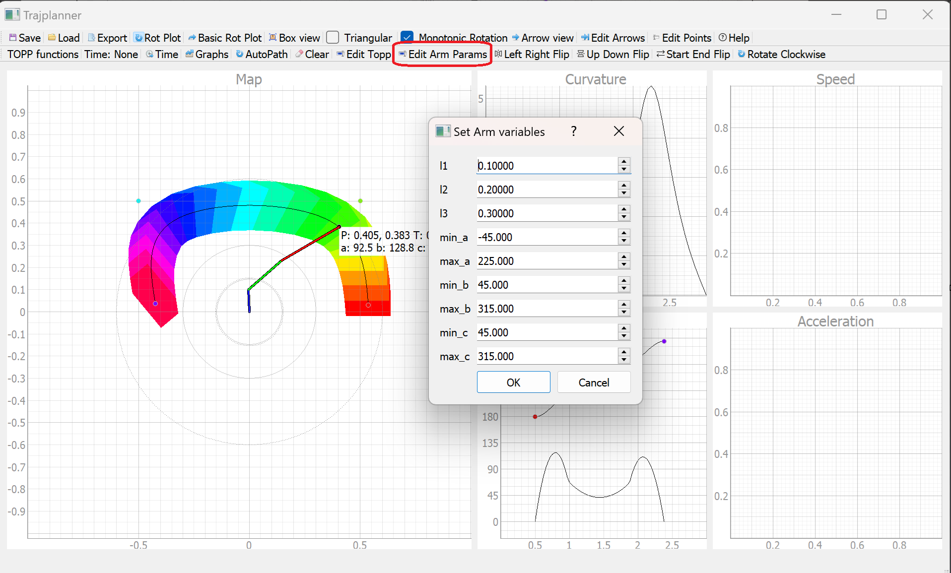
Test Result
Discontinuity in math
Since there are multiple answers for coordinates control, I have to determine which answer to choose for the answer I need. But if I simply use if cases to determine the answers, there will be a discontinuity between the true and false condition of the if cases. So, the robotic arm might suddenly jump from 1 answer to another and accidentally broke itself.

Inaccurate angles
Since there are some backlash in the motors, gears, belts of the joints, the robotic arm could not move to its target position accurately. As the arm tends to drop downwards due to gravity, when I try to move to the dark red/blue position, it can only reach the red/blue positions. So, when the arm is passing through the middle (gray), the arm would suddenly fall from the right to the left due to gravity of the backlash. So, its position suddenly change a lot even when my target position doesn’t change much.
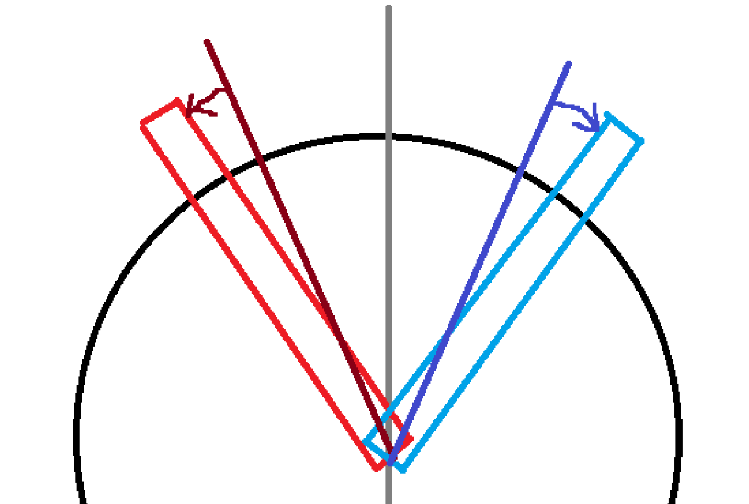

Summary, Improvement and Further Development
Some old seniors say that robotic arm are too general and will never be the best solution for Robocon competitions. Since the best solution every year is very game-prop specific.

Some people say robotic arm is too complex and has way too many degree of freedom. This might increase the chance of failure and lengthened robot tuning time.

I think some simple robotic arms are necessary for some sort of loading and putting mechanisms so I think it still worth to further develop.

Part 2 – Reflection Report
The following questions aim to assist you in recalling and reflecting on your experience in the Robotics Team.
- Are there any memorable incidents or stories? What did you learn from the experience? (at least 150 words)
One February/March Night around 2/3 am, I am the only SW tuning the robot in lab(with a few mech drawing Solidworks). Since I am the only one using the game field and no one will have merge conflict with me, my efficiency boosts to 200%. I was holding the controller with my right hand to test the robot while holding my phone with my left hand for video recording. After testing, I modify the code on my laptop with my right hand while plugging the ST-Link into the robot to flash the code with my left hand. Then, I reset all 12 seedlings on the gamefield by myself and start testing the new modified code. The performance of my robot improves significantly during this time. The time needed for R1 to finish Area1 drops from 29.048s => 26.058s => 23.048s in 1 night.

From this experience, I learnt that I am more suitable for working alone in night shift. That’s why I assigned myself to work in night shift during the whole Easter holiday and the final day night shift period. I also rediscover the fire, or the passion for robotics within me.
- What were your personal and team goals? To what extent have you achieved them? (at least 150 words)
My personal goals were to train up my juniors such that my juniors can achieve much more than me. My juniors can handle the robot without me during test runs and rehearsal day. I believe they can handle their robots next year.

Our Team Goal for R1 Team was to create a R1 that is faster than all R2. Our R1 is the fastest among the world and is faster than all R2 around the world. Our R1 can support any R2 to achieve their highest possible speed.
- What factors do you think facilitated or affected the achievement of your goals? (at least 150 words)
The sense of achievement is the key to motivation. When I succeeded created a new feature/achieved great improvements on robot speed, I would be highly motivated and it highly facilitate the achievement of my goals. This is also the key reason why so many SW juniors stay next year.
On the other hand, HW are just doing cheap labour work. Their HW R&D Taobao never arrives. They couldn’t achieve anything so they have no motivation to come to lab. So, this is also the key reason why nearly no HW juniors stay next year.
- How will you apply what you have learned in the future? (at least 150 words)
The technical skills are some valuable experiences that I can apply in my further studies. If I didn’t join robotics team, I would have a hard time learning embedded system, Bezier curves, advanced C, machine learning, etc. These are some useful skills that I can apply in my FYP and my future career.

The soft skills such as organizing meetings, preparing tutorials, teaching juniors, progress management that I learnt in robotics team are also useful for my future studies and career. I can apply these skills in organizing next year’s RDC and managing my FYP.
- List any other comments or suggestions for the HKUST Robotics Team, the sub-team, and/or its departments (Mechanical / Electronics / Software / Business / Management).
Hall 8 lab is really far away from the main academic building. We need to walk 15 minutes down to lab and another 15 minutes up every day. So, not many old members would come to our lab to give advice on the competition teams. So, the experience of our old members can’t be passed down and we will lose our technologies and knowledge after a few years.

Since Hall 8 lab is far away, team members would not/could not come down to lab when they have 1.5/3 hours gap time between their lectures. Team members wasting 30 minutes/day to travel to lab + 30 minutes/meal when they need to go to eat. This significantly reduces our overall robot tuning time and reduces our overall performance these few years. To overcome this problem, many members decided to sacrifice their academics by not joining lectures/ sacrifice their health by not sleeping. Although this would allow us to chase back the lost time, but this would greatly reduces the quality of work and reduces the overall performance.
- Based on your above comments or suggestions, how can you help the HKUST Robotics Team to be better?
I would leave more documentations such that future people can easily pick up my knowledge. I would also go down to lab whenever I have time to give them more advice for future competition teams.
- What would you expect from our TA?
To monitor our overall progress and urge us to finish some key-tasks on time.
To guide us on the right track such that we won’t waste too much time on the wrong direction.
To keep track of team members’ health condition and force people to rest when they need to.
To teach seniors how to do administrative and management tasks
Part 3 – Survey (Your Teamwork Experiences and Perceptions)
Please respond to the following questions according to what you believe. There is no right or wrong answer. We simply want to understand your view about teamwork.

1. Amy, Kevin and two other teammates were having a team discussion. Kevin proposed an idea. The other teammates supported it. Amy believed that Kevin’s idea could cause some problems but she was not sure. She decided to keep quiet in the discussion and collect some more information after the meeting by herself to verify the idea.

What do you think of Amy’s behavior in terms of teamwork?
A. Contributes to teamwork.
B. Does harm to teamwork.
C. No effect on teamwork.

Answer of Q1:
B

If you were Amy, what would you do?
Tell others that I have doubt on Kevin’s ideas. Then try to rephrase/re-organize why I think Kevin’s idea could cause some problems.

2. Four people were working on a robot design. Jack and James lived in the dormitory on campus while the others did not. The schedule was tight. Jack and James wanted to have meetings in late evening. The other two teammates disagreed. Jack and James decided to meet first and talk to the other two teammates later.

What do you think of Jack and James’s behavior in terms of teamwork?
A. Contributes to teamwork.
B. Does harm to teamwork.
C. No effect on teamwork.

Answer of Q2:
A
If you were Jack or James, what would you do?
Host mixed mode meetings such that all members can join whether they are in lab or in home.

3. Mark, Paul and three others members were organizing a student society activity. Mark and Paul had strong disagreements on the event rundown. Paul used Whatsapp messages to contact the other three members individually to explain his idea.

What do you think of Paul’s behavior in terms of teamwork?
A. Contributes to teamwork.
B. Does harm to teamwork.
C. No effect on teamwork.

Answer of Q3:
B
If you were Paul, what would you do?
I would explain my idea in Whatsapp group chat so that everyone knows what I am thinking instead of explain it individually.

Your teamwork experiences

- What is your conception of teamwork? What are its major components?
I believe teamwork is that everyone works on what they are most familiar or what they are the best in and everyone helps each other’s out when other people need them.

- What do you enjoy the most in the Robotics Team over the past year?
I enjoy creating new features and successfully implement them.

- What could be done better in the Robotics Team over the past year?
We could make Gen0 R2 much more earlier for SW to test.
We should host more meetings for discussing the sketches of the robot before mech drawing it.
SW and HW can be more active on reviewing and commenting Mech’s Solidworks.
HW can come to lab more often to help Mech and SW.

